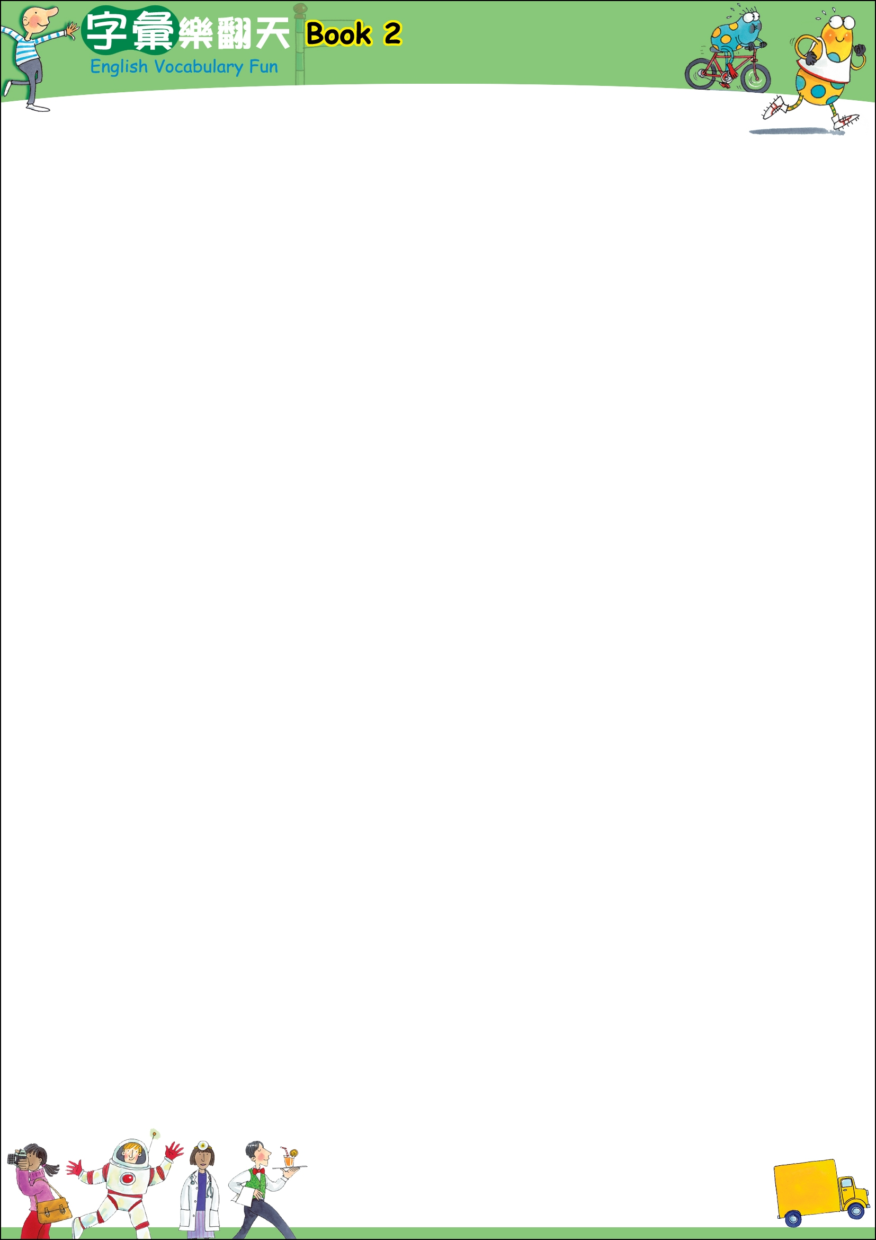

Book 2 L:1 Plants
SITUATION: Pokky (blue guy) follows Dokky (yellow guy) when he goes to water a sunflower. Dokky doesn’t realize there is a hole in his watering can, and he can’t hear Pokky over his singing.
Target Language: Where is ?
New Words: water（澆水）、follow me（跟我來）、slow down（慢一點）、empty（空的）、sunflower（太陽花）、past （經過）
1.  P: What are you doing, Dokky?  D: Getting some water to water the big sunflower.  P: Where is the sunflower? | 2.  D: Follow me and I’ll show you.  P: Umm, Dokky…
3.  D: Let’s go. Doo Doo La Da Dee Dee Doo  P: Umm, Dokky…Dokky, the water. | 4.  P: Yoo Hoo, Dokky, slow down!  D: Now where is that sunflower? Oh! I remember now. It’s past the bush and past the pond.
5.  P: DOKKY! You’re only watering the green grass!  D: Doo Doo Doo La La La | 6.  D: There is the flower. Hey, the watering can is empty. Where is my water?  P: I wonder!

Do you have a garden?
Do you have any plants at home?

Book 2 L:2 Flying Things
SITUATION: Pokky cleverly uses her sweater to fly a kite, but she gets into trouble.
Target Language: My kite is flying higher than .
New Words: sweater（毛衣）、barely（勉強地）、beat（擊敗）
1.  P: I’m so smart. I’m using my sweater to fly my kite! Wee! | 2.  P: Ah! A bee. Higher! Higher!! My kite is flying higher than a bee. Ha Ha! You can’t beat me, Mr. Bee.
3.  P: Oh! My kite is flying higher than a fly! Ha Ha Ha. Bye-Bye, Mr. Fly. | 4.  P: Whoa Whoa Wee, this is fun! Oh, what a beautiful butterfly! Fly high in the sky, Mrs. Butterfly.
5.  P: Wow! My kite is flying higher than a helicopter. | 6.  P: Woo…! A plane! I can barely see my kite. What…? How…? Why…? Where did my sweater go?!

Can you fly a kite?

LESSON Book 2 L:3 Numbers
SITUATION: Pokky and friends count together.
Target Language: There are .
New Words: climb up（爬上來）、try someone’s best （盡力做好）、be careful（小心！）、bottom（底部）
1.  P: One Pokky | 2.  P: Hi! Now there are two Pokkies!
3.  P: Yeah!!! One more Pokky! That makes three. | 4.  P: Hey, come join us!  P#4: Me?  P: Yes, you! Now there are four of us.
5.  P: Climb up! How high can you go?  P#5: Oh! I’ll try my best!  P: Good job! Now there are five Pokkies. | 6.  P: Up and up, up and go. Oh, yeah!  There are six Pokkies already.
7.  P# all: Yes, seven Pokkies. Wee… | 8.  P# all: Whoa, Whoa, Whoa! Be careful! Pokkies, wow… Yeah! Higher and higher.
9.  P# all: Nine Pokkies.  Wow! Wow… wow, one more,  one more. | 10.  P# all: Yeah, ten Pokkies!  P: Yeah, I am on top! I’m the king of the world!  P #10: Hey! Why I am on the bottom?

Can you count the numbers from ten down to one?

Book 2 L:4 Colors
SITUATION: Dokky is exercising.
Target Language: He’s / She’s wearing a hat.
New Words: a little bit（有一點）、concentrate（專心）、exercise（做運動）
1.  D: One, two, one, two! Just one more!! I can do it. Oh! What a pretty red hat! | 2.  D: Oh! Look, he’s wearing a blue hat! I like blue. Wow! Oh! This is a little bit heavy. Concentrate!
3.  D: Just one more…Oh, look! He’s wearing a green hat. Wow, wow, wow! Almost there! | 4.  D: Oh, she’s wearing a very pretty orange hat. I want the flowers on it. Oops, I must concentrate. I can do one more!
5.  D: Wow, wow! I can’t do it! My legs! He’s wearing a yellow hat. Nice color! Nice hat…ha… hel… heeelp! | 6.  P: Help is here!  D: Hey, look! He’s wearing a pink hat.  P: You need to exercise more!

How often do you exercise every week?

Book 2 L:5 Parts of the Face
SITUATION: Bonkers the clown is putting on his makeup when his reflection gets upset.
Target Language: I have .
New words: brush teeth（刷牙）、squeaky（短促尖聲的）
1.  B: Brush, brush, brush my teeth, round and round in small circles. | 2.  B: Pop, pop. One ear, two ears. I have two big ears.
3.  B: One circle, two circles. Now I have two beautiful blue eyes. | 4.  B: Mustn’t forget my squeaky red nose. Now, I have a red nose.
5.  B: Whoop! Next, my happy red mouth. Now I have a happy red mouth. La La Whoop … | 6.  B: And last …crazy green hair. What? No hair? You don’t like the hair?

Would you like to be a clown?

Book 2 L:6 Animals
SITUATION: Pokky is entertaining herself with animal shadow puppets.
Target Language: I can make a .
New Words: shadow（影子）、hump（駝峰）
1.  P: I can make a funny shadow monkey. Oh, Oh, Oh. | 2.  P: One hump, two humps! I can make a camel with two humps. Wee! This is fun.
3.  P: I can make a fat, fat hippo. Run, hippo! Ha Ha Ha Ha! | 4.  P: Wow. I can make an elephant! Wee! I’m the best!
5.  P: Roar! Here’s a big brown bear. | 6.  Shadow Animals: Ahh! Run! A dinosaur!  P: Huh!

Do you know how to make a shadow animal?

Book 2 L:7 Places Around the World
SITUATION: Dokky is going on a trip in a rocket and Pokky wants to join him.
Target Language: I can see .
New Words: rocket（火箭）、boat（船）、snow（雪）、below（在下方）、take off （起飛）、space（太空）
1.  D: Wee! This a good place to take off, Pokky. Get ready! We’re going to travel in space!  P: BLAST OFF! | 2.  D: Oh! I’m so high already! I can see a road.  P: Bye!
3.  D: Wow, I can see a boat on a river. Vroom! | 4.  D: Woo! I can see a forest. There are so many green trees in the forest.
5.  D: Faster, faster, over the lake. Wee! | 6.  D: Oh, look! An island. I can see a small island. Hello, island people.
7.  D: Mountains! Wow. I can see snow on the top. Brr! | 9.  D: Up, up, up and away! Wow! I can see the world!  P: Hey, Dokky, wait for me!
8.
D: Hey, there is my city below! Hi, Mom!

How does Pokky catch up with Dokky?
Would you like to travel in space?

Book 2 L:8 Space
SITUATION: Pokky is going on a space mission.
Target Language: Such a .
New Words: fluffy（蓬鬆的）、bright（明亮的）、sleepy（想睡的）、shiny（閃耀的）
1.  P: Goodbye, everyone! Wee! I’m going in a spaceship. | 2.  P: Look. Such a fluffy white cloud.
3.  P: Woo! It’s so hot! Such a bright yellow sun. | 4.  P: Oh, such a sleepy moon. I need some tea.
5.  P: My tea is ready. Such shiny stars. | 6.  P: Now, it’s tea time.  P: A yellow planet! Oh! That’s not a planet, that’s Dokky!  D: Clean Clean Clean Dee Dee Dum…  P: Dokky!!! Why are you here?

What is Dokky doing?

Book 2 L:9 Prepositions
SITUATION: Pokky is making a huge snowball.
Target Language: I am the snowball.
New Words: snowball（雪球）、squeeze（擠）
1.  P: Wee! I love snow! Look at me. I’m sitting on a snowball. | 2.  P: Ha Ha Ha…, I am in the snowball. Help, help, Ha Ha Ha.
3.  P: Hey! Can you see me? Where am I? Hee Hee Hee, I’m behind the snowball. | 4.  P: Squeeze, squeeze! Oh, oh, almost! I did it! Yeah, I’m between two snowballs.
5.  P: Now I’m in front of the snowball. Oops! Uh-oh! | 6.  P: Ahh, help, help! I’m under the snowball. Ahh!

Where is Pokky, now?
Have you ever played in snow?

Book 2 L:10 Sports
SITUATION: Pokky tries to find her favorite sport. She tries everything from hockey to tennis.
Target Language: I’m good at .
New Words: miss（錯失）、slam dunk（灌籃）
1.  P: I’m good at hockey. Oh, I missed it. I don’t want to play hockey. | 2.  P: Maybe I’m good at soccer. … Maybe not.
3.  P: Now, tennis is my sport. I’m good at tennis. Okay, what’s next? | 4.  P: Hey, Meatball, Dokky, can you help me out of the sand? I want to play volleyball, too.
5.  P: Of course, I’m good at baseball. Ahh…, someone threw a ball at me. Baseball is dangerous! | 6.  P: Hmm…, I have an idea!  I’m not just playing basketball, I am a basketball! Wee!

What kinds of sports are you good at?

Book 2 L:11 Kitchen Utensils
SITUATION: Dokky is making some toast and setting the table.
Target Language: I need .
New Words: toast（土司）、burn （燒焦）
1.  D: It’s time for breakfast. What do I need? Hmm…I need a knife. Wow! Be careful. | 2.  D: Toast, Toast, I love toast. Now, put the bread in the toaster. Yes, I need a fork, too.
3.  D: Ah… I think I need a spoon. A fork and spooooooooooon. Hee Hee Hee, sppppooon. Such a funny word. | 4.  D: I need my little blue bear cup. Sit on the table, little bear!  OS: What’s that smell?
5.  D: I can’t forget my kitty plate. Meow! Good Kitty! I need you, too.  OS: Something is burning! | 6.  D: And last but not least, my super special bowl…Oh, no! MY TOAST! Come back!

Do you think the toast can still be eaten?
What do you usually eat for breakfast?

Book 2 L: 12 At the Beach
SITUATION: Pokky and Dokky are at the beach.
Target Language: Maybe he is .
New Words: footprint（腳印）、crocodile（鱷魚）
1.  P: Look, a duck’s footprints in the sand.  D: I don’t think so. I think they are a crocodile’s footprints! | 2.  D: Follow me, Pokky! One, two, one, two.  P: One, two, one! Oh, look, a shell.
3.  D: We’re getting closer, Pokky!  P: Maybe he is by that tall cliff. | 4.  D: Ahh!  P: What?  D: I’m sooo scared. Maybe it’s hiding in the sea.
5.  D: Hold my hand, Pokky. Relax!  P: Maybe it’s over there by the rocks. Ooh, a scary cave. Let’s go inside!  D: Nooo, I’m too scared! | 6.  P: Dokky, it’s just a man! He is wearing a diving suit. We don’t need to be scared.

Why do they high-five each other?

Book 2 L:13 Objects in a House
SITUATION: Dokky gets mud all over Pokky’s house.
Target Language: There is a .
New Words: take off（脫掉）、clean up（清潔）、boots（靴子）
1.  D: Now, where is the keyhole? | 2.  D: Open Sesame! Oops! I should take off my dirty boots before I go inside.
3.  D: Doo Bee Doo La La. Oh! There’s a picture. It’s Pokky. Nice picture. | 4.  D: Doo Doo Lee Boop One, two, three, four Ahh! There is a nice bed next to the wall.
5.  D: Doo Bee Doo La La … There is a window. Oh! Was that Pokky looking through the window?  P: Hoo! My carpet. Dokky...!! | 6.  D: La La La Lee Doo Bee. It’s okay, I’ll go clean it up. I just need my boots!  P: No boots, and get cleaning! It’s already two o’clock and my mom is coming at three. Hurry…

Why is Pokky so angry?

Book 2 L:14 Clothing
SITUATION: Pokky is skating through the clothes on a line.
Target Language: I got it!
New Words: superhero（英雄）、pole（ 竿子）
1.  P: Wee, Wee, faster faster! Look out, a coat! I got it! | 2.  P: Yeah, I’m a superhero! Look, a jacket. Woosh, yeah! I got it!
3.  P: Wee! Whose clothes are these? Oh, look, blue trousers, I got them! | 4.  P: What’s next? A pretty flowery dress. Whoa Ho …I got it!
5.  P:Vroom! There’s a t-shirt straight ahead! Ahhh, now I can’t see anything. | 6.  P: Oh, no! I saw a pole behind those sneakers.

What did Pokky do that was wrong?

Book 2 L:15 People
SITUATION: Dokky is going to see a doctor because he is sick.
Target Language: Thanks for , .
New Words: sick（生病的）、tissue（衛生紙）、space（太空）
1.  D: Oh I’m soo sick. Everyone is sick, even that student. He’s got a broken arm. | 2.  D: The builder has a bad cold.
3.  D: Thanks for taking my picture, photographer, but no pictures while I’m sick, please. | 4.  D: Oh, poor astronaut. He’s cut his finger.
5.  D: Finally, a doctor! Doctor, I think I’m dying.  Doctor: Take it easy! You are not.  D: Thanks for seeing me, doctor. I feel much better now. | 6.  D: Much better! Doo Doo Laa Lee Lee … Oh, this waiter has hurt his neck. I don’t think he can see me.

Do you usually see a doctor when you are sick?

Book 2 L: 16 Where to Go?
SITUATION: Dokky and Pokky are deciding where to go.
Target Language: Let’s .
New Words: go skating（溜冰）、sandcastle（沙堡）、Geronimo（人從高處跳下時的吶喊聲）、 popcorn（爆米花）
1.  P: What do you want to do today, Dokky?  D: Let’s go to the zoo! | 2.  D: No! Let’s go skating in the park. Wee …
3.  P: No! Let’s go to the beach. We can build sandcastles. Woosh! Woosh! | 4.  D: How about going to the swimming pool! Geronimo!
5.  P: I know. Let’s go to a movie at the cinema.  P and D: POPCORN! | 6.  D: Hey, Pokky, what day is it?  P: It’s Friday. Why?  D: We have to go to school!  Ahh.

Have you ever been late for school?
Why were you late?

Book 2 L:17 I Love Exercising
SITUATION: Dokky is running and slowly gets exhausted.
Target Language: That looks easier.
New Words: tired（疲累的）
1.  D: Jog, jog, jog. Wee, I love jogging. | 2.  D: Vroom. Wow, look at Pokky. She is riding her bike. That looks easier. Go, Pokky!
3.  D: Woo, this is a little hard! Go, Dokky, go! Oh, I wish I could skate or skateboard. That looks easier. Woo. | 4.  D: Maybe I could go sailing or fishing. They both look easier. Woo! Just a little further.
5.  D: Oh, I’m so tired, but almost there. Oh, I’m so glad I don’t have to climb a mountain now. | 6.  D: I am so tired. I just want to sleep, but I must keep jogging.

Why does the vulture look at Dokky?

Book 2 L:18 Do You Love to Read?
SITUATION: Pokky is too busy reading to realize what is happening around her.
Target Language: I must .
New Words: interesting（有趣的）、sign（標誌）
1.  P: I love to read. This book is very interesting. | 2.  P: Who wants to paint when you can read?  Background men: hey!
3.  P: No time to eat, I must read!  Background men: hey! | 4.  P: Oh, what is going to happen next? No time to drink, I must read.  Background men: hey!
5.  P: Was that a red light? Too late! I must read! | 6.  P: Now that’s an interesting sign.  I must read it. D-A-N-G-  …Ahh!

What kinds of things do you enjoy reading?

Book 2 L:19 What Can You Do?
SITUATION: Dokky likes singing while he is working.
Target Language: Don’t , I almost fell.
New Words: fall（墜下）、watch out（小心）
1.  D: La La La Lee Lee La I love to sing while I’m working!  P: Hey Dokky, look how fast I can  walk. Vrrooooom.  D: Wow, Pokky. Don’t walk so fast. I almost fell. | 2.  D: Wow Wow Wow…, Don’t run! I almost fell. Whew!
3.  D: What is that? Hop, Hop, Hop, higher. Mr. Mime. | 4.  D: Oh! I really want to skip rope but I have to finish this beautiful picture. Whoa Whoa…Don’t skip so fast, I almost fell.
5.  D: There, done! Whoa Whoa Whoa... watch out! Don’t jump so fast. I almost fell. | 6.  P: Da, Da, Da. Dokkey, look at me dancing! Da Da Da….

Can you dance, sing and paint?

Book 2 L:20 Drawing a Picture
SITUATION: Pokky is at the beach drawing some pictures.
Target Language: I can .
New Words: cold（冷的）、wet（濕的）、tide（潮汐）、drawing（素描）
1.  P: Hmm! What can I draw? | 2.  P: I can draw a picture of a boy kicking a ball.
3.  P: Hmm, I can draw a boy throwing a ball …. | 4.  P: …and another boy catching it. Brr, my feet are cold.
5.  P: I know! I can draw some water so this boy can dive in the sea! Weeee, splash! Hey, why do I feel wet? | 6.  P: Ahh, the tide. My drawings, no. Oh well, I can have a nice swim now. Wee Wee…

Which do you like more, swimming in the sea or in a pool?

